1. a What else can we investigate on LED?

α) Measure the dependence of U and I at LED of various colours: yellow, green, blue, infrared (IR)
(And what about white LED?)

What is a “typical” voltage at LED? (The voltage at which the LED shines at least weakly.)
Infrared: | Red: | Yellow: | Green: | Blue:

Is the voltage related somehow with the colour of the light?
(And what about energy of photons of this colour? Is there any relation to the voltage?)

β) Try to destroy a LED by great current.
(Be careful, sometimes the cap of the diode shoots off. Do not point it to someone’s eye.)
Which is the largest current suitable for normal use?
(Try to find the catalogue values.)

γ) What is the least current at which you can still see the LED shining?
(Try to observe LED in complete dark.)
We create further simple tools
2a. Further simple tools for few eurocents

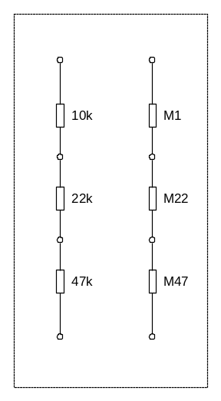
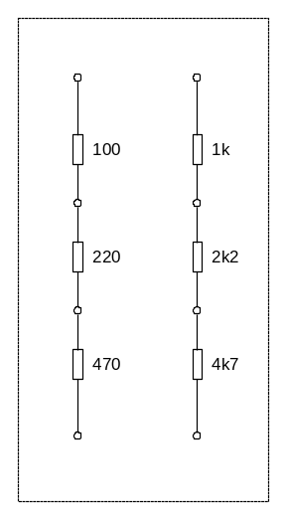
A) „Resistor triads“
They are much cheaper that rheostat or potentiometer bought in the shop.
The name was created to resemble “resistor decades”; but only 3 resistors are needed for each decade.
What is the ratio of resistances? (It is called E3 series – try to find what the series E6 and E12 are and which values of resistances are in these series.)
Find which values of resistance can we obtain easily by combining the resistance of resistors in “resistor triad”.
Resistors for power dissipation 0,6 W suit well for this purpose. For lower resistances (1 Ω to 47 Ω) the resistors of power dissipation 2 W are more suitable.

B) For those who are interested: Build anything else:
- Small wooden boards with: a) diodes b) diodes connected so they form the Graetz bridge rectifier)
- Small wooden board with Zener diode (or Zener diode with resistor making the stabilizer circuit. You can also add the capacitor to filter out the residual alternate component.
- Small wooden boards with transistors in various simple circuits – see further description.
2. b Simple tester:
Basic version: | Version B:
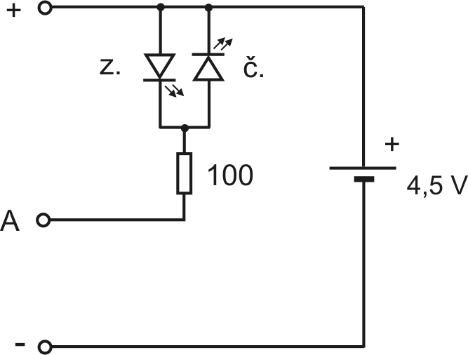 | 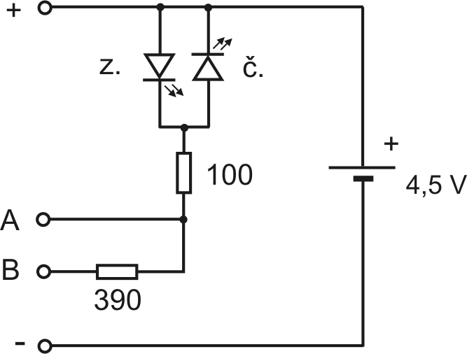
How to use such tester, for which experiments can it be used?
- To test batteries (connecting to + and A; by shining of green or red LED; it indicates also the polarity)
  - For voltage of about 3 to 8 V
  - Pro napětí až asi do 20 V (připojit k + a B )
- Tester of AC voltage (at terminals + and A resp. B; both LEDs shine, you can see them flashing when moving)
  - For voltage 2 to9 V
  - Try to connect AC source in series with normal batteries… (to terminals – and A)
- Tester of conductive connection and resistors (terminals – and A)
  - Conductive connections and resistors of small resistance (unfortunately resistors of tens of ohms and short circuit cannot be distinguished
  - Resistors up to kiloohms or even more (even the thick line made by pencil; put the LEDs into the shade to see the barely visible LED lightd)
- Tester of light emitting diodes (terminals – and A; also the LED polarity can be determined)
- Tester of diodes and transistor junctions (terminals – and A; polarity, short-circuit or breaking can be found)
- “Power source” 4,5 V :-)
  - At terminals A and itworks as a “soft” power source of about 2,5 V (the short-circuit current is about 25mA)
  - To low resistances it works as a current source (25mA, or 5 mA using – and B)
- Tester of capacitors; demonstration of charging and discharging of capacitors
  - Tester of electrolytic capacitors (of capacitance since few μF)
  - Demonstration of charging of a capacitor (add a capacitor 470 μF to – and A; the LED will flash, then dim; discharge it before next charging /see experiment c/; be careful to connect it in the right polarity)
  - Demonstration of discharging of a capacitor (connect charged capacitor to + and A)
- Demonstration of connecting resistors in parallel and in series
Observe how connection of resistors attached to terminals – and A changes the light of LED.
- Tester of transitors (and demonstration of the behaviour of a transistor)
  - Transistors NPN (connect emitter to – , collector to A, base to B)
  - For PNP transistors change the polarity of the battery
  - Using external resistor (50 to 100 kΩ) for connecting the base to + we can demonstrate how a transistor “amplifies” a current. Even the current gain con be estimated roughly.
- Tester and demonstration of behaviour of a thyristor – connect it similarly as a transistor).
You can try to find some further use.
You can use it even as an emergency torch, albeit very week Just connect – and A … :-)
3 a. Diodes – supplementary tasks
a) Measure the characteristics of a Schottky diode.
Draw the circuit diagram you use: | Write down the measured values of U and I into the table: | Draw the graph showing the dependence of U and I (characteristics of the diode)
 |  | 

What is a “typical” voltage at Schottky diode in forward bias?

b) Check the theoretical formula for the current through the semiconductor diode.
(You can find the formla in literature, on internet or just by asking.)
Is there any “border voltage” below which the diode does not conduct the current?

c) Measure the residual AC voltage at the output of a rectifier.
How is this voltage influenced by the capacitance of a filtartion capacitor?
How it depends on the current we take from the sourfce?
How is the residual AC voltage at the output of a stabilizer with Zener diode?

3b. Investigating Zener diode

a) Measure the characteristics of a Zener diode in forward bias.
(Just roughly, you do not need to draw a graph.) Does it differ from a normal diode?
b) Measure the characteristics of a Zener diode in backward bias.
(Do not exceed the current of several tens of mA.)

Draw the circuit diagram you use: | Write down the measured values of U and I into the table: | Draw the graph showing the dependence of U and I (characteristics of a Zener diode)
How the voltage at Zener diode changes with changing current?

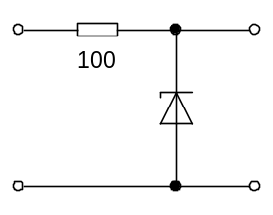
c) Explore, how to stabilize the voltage using Zener diode.
Look at the circuit diagram. Where there is the input (of unstabilised voltage) and output (of stabilized voltage)?
Explore how good is our stabilizer:
How much can we change the input voltage for the output voltage change of 0,1 V, o 0,5 V, …?
How the output voltage depends on the current we take from the stabilizer?

3b. Zener diodes – further supplementary tasks
d) Measure the differential resistance of Zener diode. Measure the internal resistance of the power source with stabiliyer using Zener diode.
e) Find absolute maximal ratings of the Zener diode you use. Think out how to derive reasonable value of resistance of a serial resistor in a stabilizer with Zener diode.

3 c. Investigating termistors and photoresistors
a) Measure the resistance of a termistor.
Observe qualitatively how it changes with temperature.

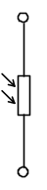
b) Measure the resistance of a photoresistor.
Observe qualitatively how it changes with changing intensity of light?

3 d. Termistors and photoresistors – supplementary tasks
a) Measure the dependance of the resistivity of a termistor on temperature.
b) Measure the dependance of the resistivity of a photoresistor at the intensitu of light.

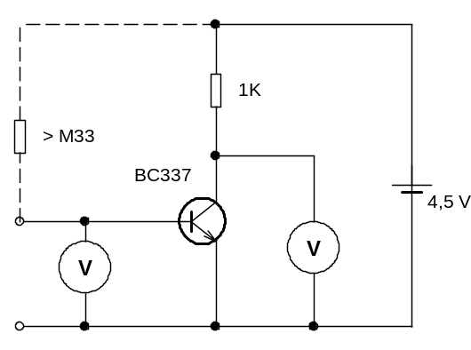
5 a. Transistor can amplify the voltage (common emitter circuit)
a) Investigate how the base voltage (of the transistor used in common emitter circuit) influences the collector voltage.
(Note: Base voltage, U_{BE} , is the voltage between base and emitter; collector voltage, U_{CE} , is the voltage between collector and emitter.
Hint:
See the circuit diagram. Change the current into the base (changing the resistance between about 0,33 MΩ and about 10 MΩ) and notice the changes of U_{BE} (these are rather small) and changes ofU_{CE} (these are lager).
U_{BE} | U_{CE} | ΔU_{BE} | ΔU_{CE} | ΔU_{CE /} ΔU_{BE}
V | V | V | V | -
What is the ratio of changes of base voltage and collector voltage? (And what is the sign of the ratio?)
* (further question): Does the gain depend on the collector current? How?
Can the amplified voltage be somehow distorted when compared to input voltage?

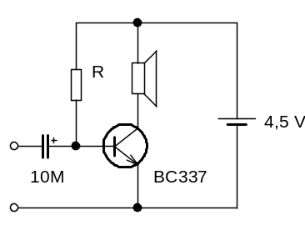
b) Build a very simple amplifier of AC voltage.
Hint:
See the circuit diagram. Se the resistance R so that the voltage at the loudspeaker is about 1 V. (The resistance of about 22 kΩ, i.e. in the range 10 až 33 kΩ, should work) Try it.
Note The resistance of the loudspeaker should be at least 8 Ω.
You can put e.g. the signal from MP3 player to the imput of our amplifier using “safety resistor” several hundred Ω in series
Note: This is the simples circuit – but not very useful for practice. (One reason is that there is a DC current gouing through the loudspeaker. Use larger loudspeakers, be careful not to damage some small loudspeaker by too high current.)

* More advanced tasks:
c) Build an amplifier using a resistor e.g. 1 K instead of the loudspeaker. (You must adjust also the resistor connected to the base, its resistance should be much higher. Could you estimate its value?) Measure the AC gain of the amplifier.
d) Build a two-step amplifier. It can amplify e.g. the signal for the earphones.
Try to connect various sources to the input – simple crystal radio, phototransistor,….
5 b. Transistors generate oscillations (let’s build a flasher or a buzzer)
Build a simple flasher with two transistors (e.g. of the type BC547) and two LEDs:
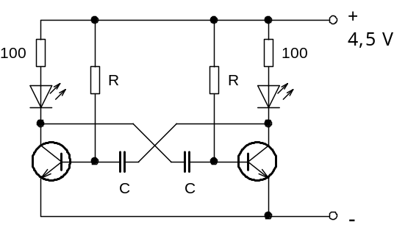
T₁
T₂
This circuit is called multivibrator.
(Why it is called so: The signal at the collector of the square waveform. This can be decomposed to harmonic oscillations of base frequency, double frequency, triple frequency, … The signal contains many frequencies, therefore we call its generator multivibrator.)
To have the period of about 2-3 s the values of components can be for example:
C = 100 μF, R = 47 kΩ.

a) Try to think out how a multivibrator works.
You can start from the state when right LED is shining and the left one not.
It means that the transistor T₁ is closed, so there is nearly the full battery voltage at its collector (actually it is slightly less due to voltage drop at the LED but we will neglect it here).
Transistor T₁ then starts to open (there is a current going to its base through the resistor R). Therefore the voltage at its collector starts to decrease. This decrease transmits through the capacitor to the base of T₂ – and T₂ will start to close. So the voltage at the collector of T₂ will start to increase. This increase will be transmitted via the capacitor to the base of T₁, it will open even more … and due to this positive feedback both transistors flip their states very quickly: T₁ will be open (left LED is shining), T₂ closed.
Now: T₂ is closed because the voltage at its base is negative (the voltage at the right capacitor cannot change so quickly and the collector voltage dropped nearly to zero, so the resulting voltage at base of T₂ must be negative now). But the capacitor then charges gradually due to the current through the right resistor R. When the voltage at the base of T₂ is high enough, T₂ starts to open … and the circuit flips again. And so on and so on. It may seem complicated at the first sight but it can be comprehended.
b) Try to use the capacitors of higher (or lower) capacitance. How the period changes?
c) Try how the period is influenced by changing the value of resistors R.
d) Check that the period is proportional to the product RC.
(* What is the coefficient k in the formula T = k∙RC ?)
e) * Try to make the circuit non-symmetrical. (You can change the resistance of just one of the resistors R.) What will be the duration of shining of the first and the second LED?
(Note: The term duty cycle is used to described different duration of shining of both LEDs. When the multivibrator is symmetrical, the duty cycle is 50%, or 1:1. If the circuit is non-symmetrical, the duty cycle can be e.g 1:2, 1:10, …)
f) Use the capacitors of thousand times lower capacitance (0,1 μF). How LEDs are shining?
Use a loudspeaker or earphones instead of one LED. What will you here? (We created a buzzer…)
g) * More advanced task: Build a multivibrator with high frequency (say, 1 kHz) and controllable duty cycle to control the brightness of LED.

